7/1/2025

Data Storage Solutions

Dr. Muhammad Iqbal

Leandro G. Damasceno ID 2019299

2019299@student.cct.ie

<https://github.com/LeandroGD2017/RepeatCA-Muhammad>

Contents

1. 1

2. 2

3. 3

4. 4

5. 4

6. 5

7. 5

8. 6

9. 6

10. 7

11. 7

12. 8

Reference 9

# 1.

Hadoop Installed

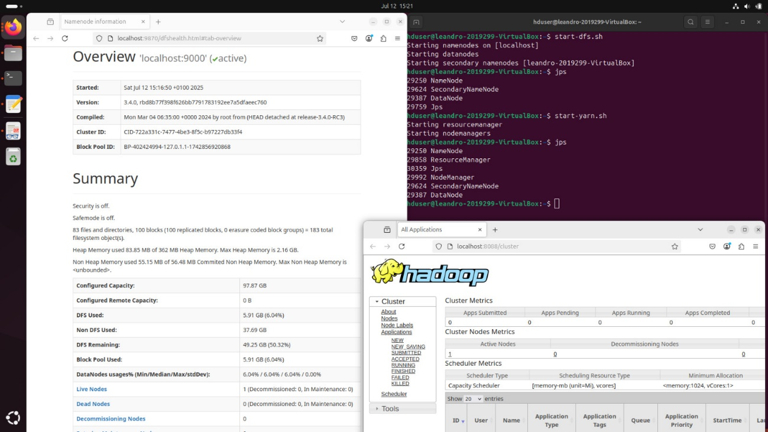

# 2.

hadoop jar /usr/local/hadoop-3.4.0/share/hadoop/toos/lib/hadoop-streaming-3.4.0.jar \

-input /user/hduser/ev_project/Electric-Vehicle.csv \

-output /user/hduser/ev_project/output_ev_by_year \

-mapper mapper.py \

-reducer reducer.py \

-file mapper.py \

-file reducer.py

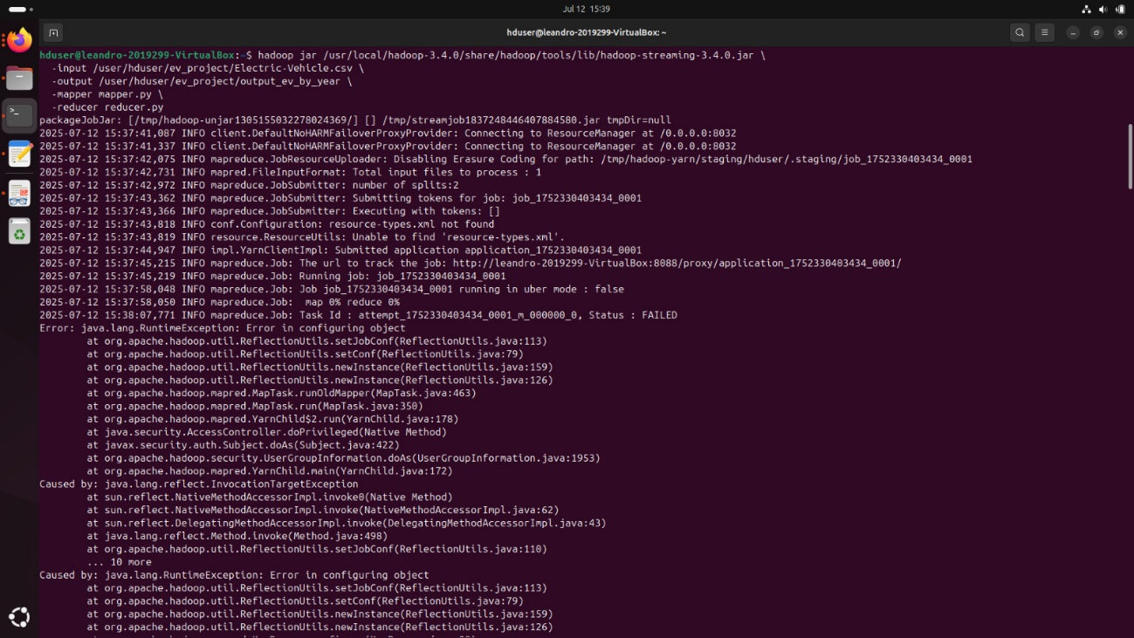

# 3.

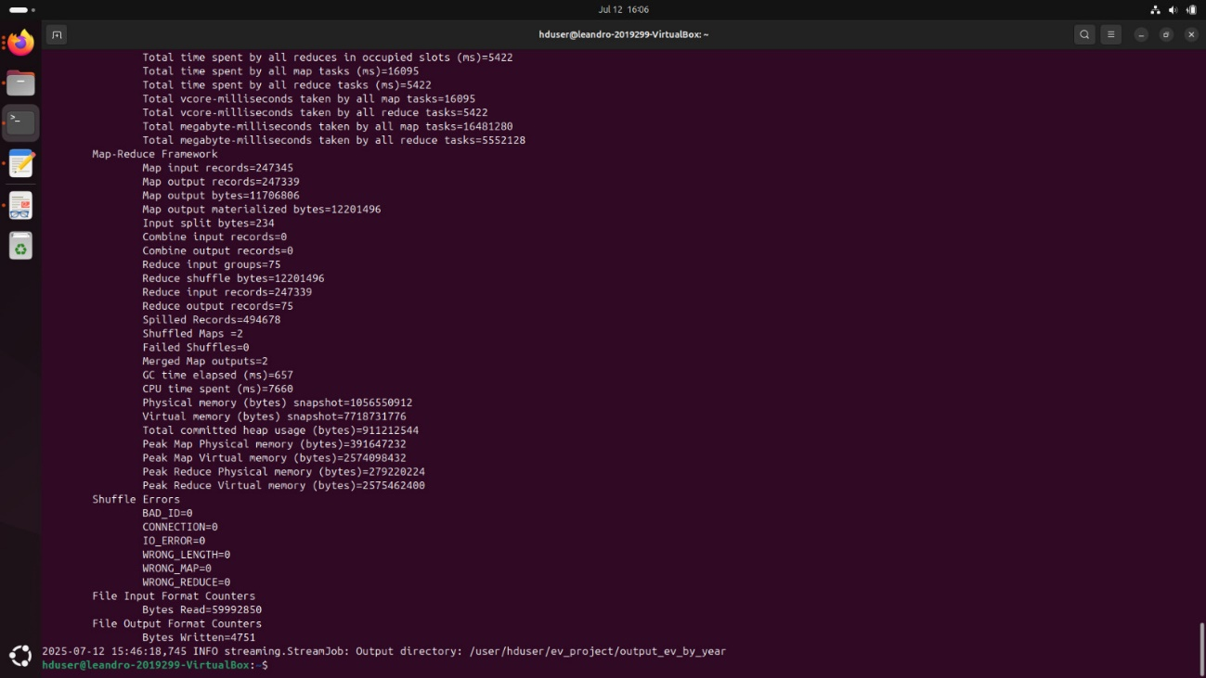

# 4.

hdfs dfs -cat /user/hduser/ev_project/output_ev_by_year/part-00000

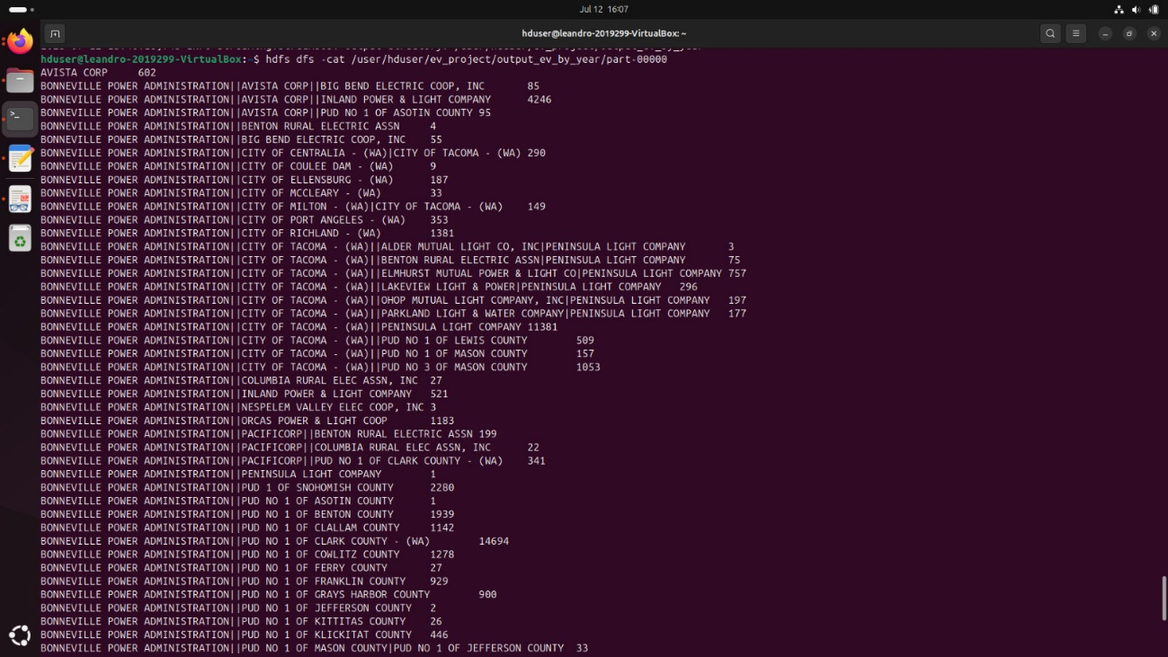

# 5.

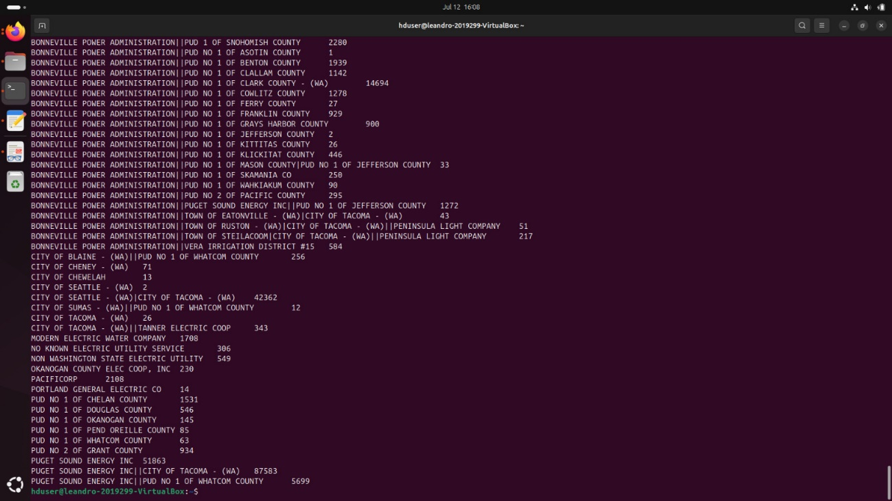

I had, a lot of problems with my Ubuntu version 24.4.2 and Mongodb refused worked with it using VM, I had to use docker.

# 6.

mongoimport --db ev_db --collection vehicles --type csv --headerline --file

/home/hduser/Downloads/eletric/Electric-Vehicles.csv

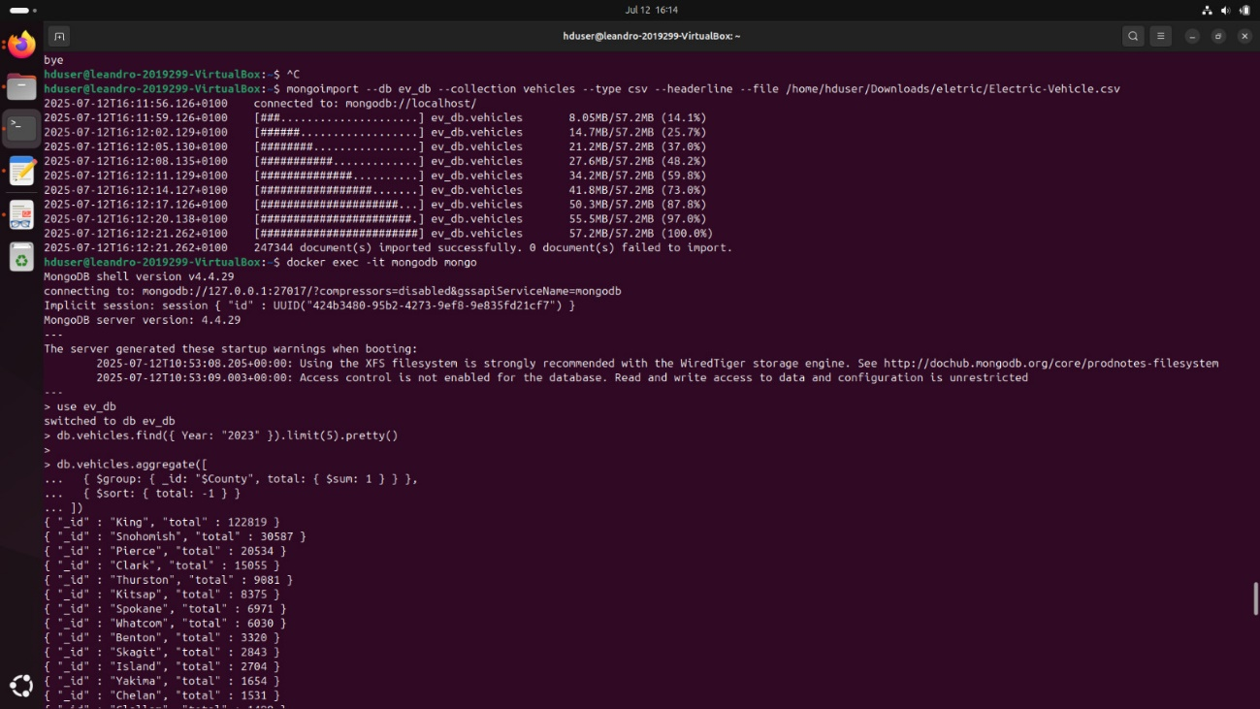

Docker exec -it mongodb mongo

Use ev_db

# 7.

db.vehicles.find({ Year: “2023” }).limit(5).pretty()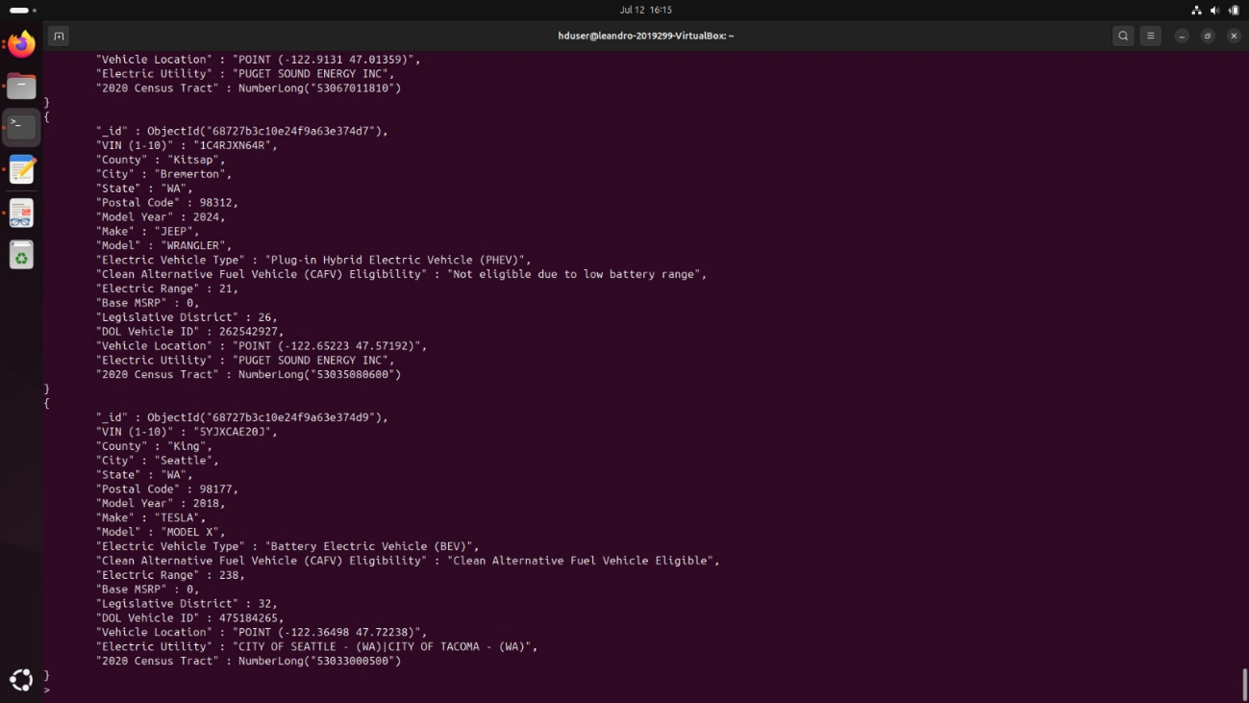

# 8.

bin/ycsb load mongodb -s -P workloads/workloada -p recordcount=50000 -p

mongodb.url=mongodb://localhost:2707/ycsb > loadA.txt

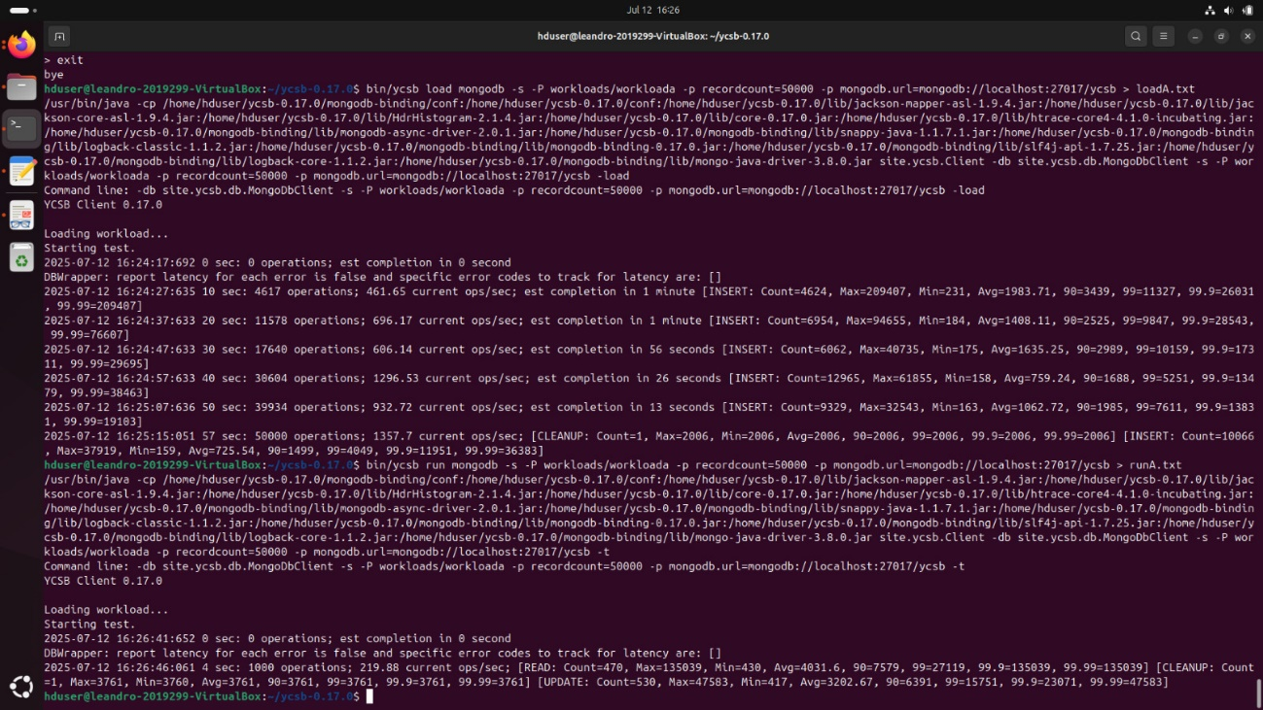

# 9.

bin/ycsb run mongodb -s -P workloads/workloada -p recordcount=50000 -p

mongodb.url=mongodb://localhost:2707/ycsb > runA.txt

tail -n 20 runA.txt

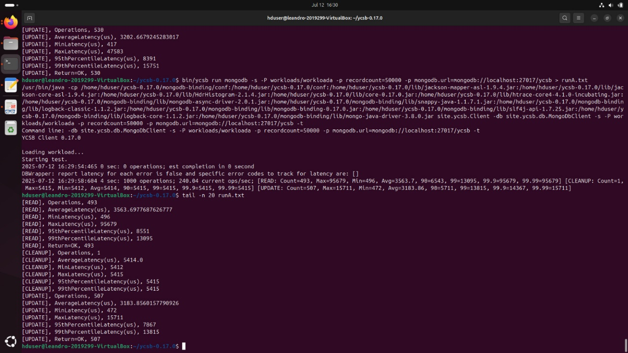

# 10.

bin/ycsb run mongodb -s -P workloads/workloadb -p recordcount=50000 -p

mongodb.url=mongodb://localhost:2707/ycsb > runB.txt

tail -n 20 runB.txt

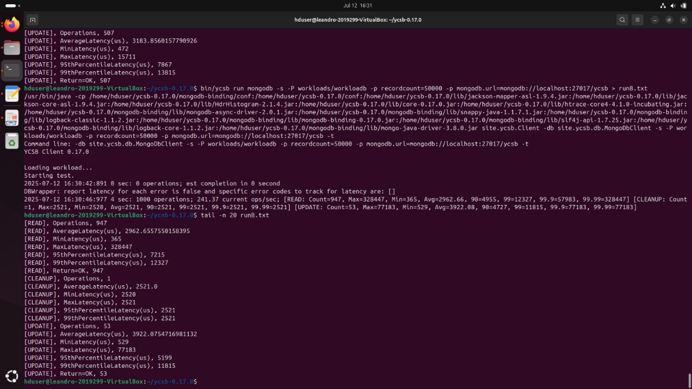

# 11.

bin/ycsb run mongodb -s -P workloads/workloadc -p recordcount=50000 -p

mongodb.url=mongodb://localhost:2707/ycsb > runC.txt

tail -n 20 runC.txt



# 12.

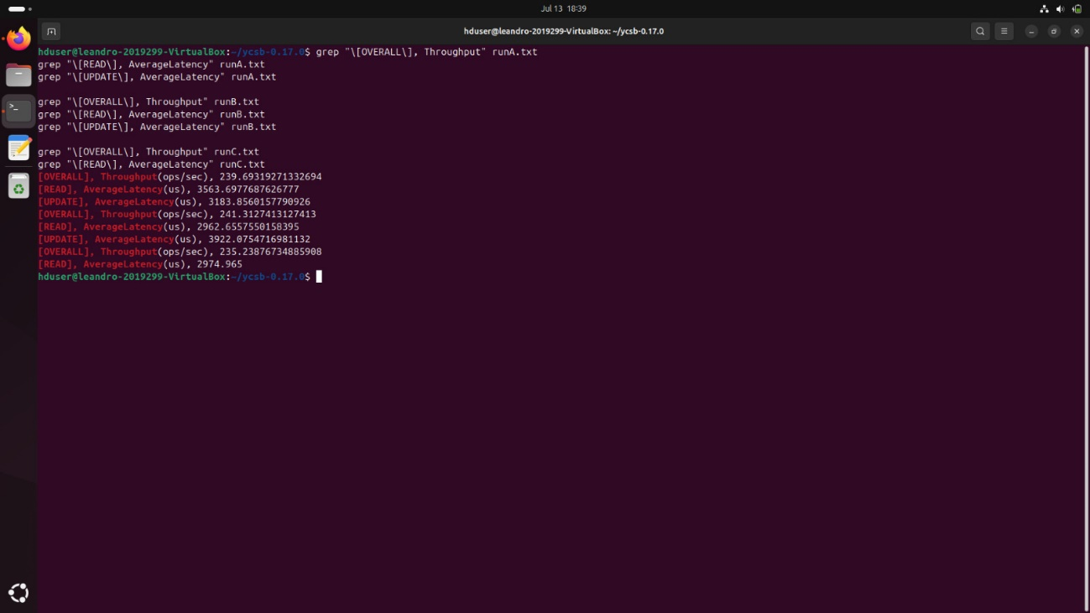

# Reference

<https://catalog.data.gov/dataset/electric-vehicle-population-data>